X`
LithiumMoto Catalog
Ⅰ. Charger series

On Board Chargers/Portable Chargers with choice of plugs
Input Voltge |  | AC 220v ± 15% (only)
Configuration (optional) |  | On-board charger standard ：  - Input plug（optional）  - Output connector（optional）  - Charging indicator(Built -in or External)  - Handle (optional)  - Auxiliary power 12v 3a/5a (optional) 12v 3a/5a
Model  One E | Rated Voltage  （V) | Max Output Current  (A) | Size (mm) |  |  | Weight (kg) | Pictures
 |  |  | L | W | H
OneE-ES- 2000w-1  Input ≤12.5A | 12/24 | 40 | 280 | 155 | 115 | 4.5 | 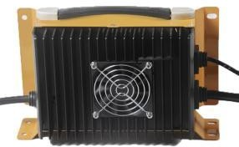
 | 36/48/60 | 30
 | 72 | 25
 | 80/84 | 20
 | 96/108 | 18
OneE-  ES-2000w-P  Input ≤12.5A | 24 | 40 | 288 | 162 | 94 | 4.5 | 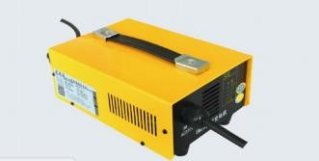
 | 36 | 30
 | 48 | 35
 | 60 | 30
 | 72 | 30
 | 84 | 18
 | 96 | 15

Input Voltge |  | AC 90V-264V
Configuration |  | On-board charger standard ：  - Input plug  - Output connector  - Charging indicator(Built -in or External)  - Handle  - Auxiliary power 12v 3a/5a (optional) 12v 3a/5a  - CANBUS:Not
Model | Rated Voltage  （V) | Max charging Voltage (V) | Max output Current |  | Size (mm) |  |  | Weight (kg) | Pictures
 |  |  | 220v AC | 110v AC | L | W | H
EX- 480W  Input ≤3A | 12 | 15 | 15 |  | 183 | 106 | 69 | 1.7 | 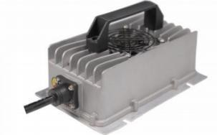
 | 24 | 30 | 15
EX- 600W  Input ≤3A | 12 | 15 | 30 |  | 193 | 124 | 67 | 1.8
 | 24 | 30 | 20 | 15
 | 36 | 45 | 12 | 8
 | 48 | 60 | 10 | 6
ES- 800W  Input ≤6A | 24 | 30 | 15 | 10 | 190 | 140 | 74.5 | 2 | 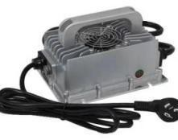
 | 36 | 45 | 15 | 15
 | 48 | 60 | 15 | 12
 | 60 | 75 | 12 | 8
 | 72 | 90 | 10 | 6

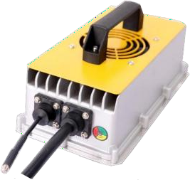
Model  OneE | Rated Voltage  （V) | Max charging Voltage (V) | Max output Current |  | Size  (mm) |  |  | Weight (kg) | Pictures
 |  |  | 220v AC | 110v AC | L | W | H
EX- 1000W  Input ≤6A | 24 | 30 | 25 | 20 | 232 | 127 | 112 | 2.5
 | 36 | 45 | 20 | 15
ES- 1500w  Input ≤11A | 12 | 15 | 30 | 30 | 282 | 146 | 82 | 3 | 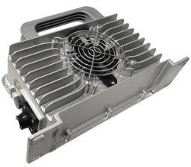
 | 24 | 30 | 30 | 30
 | 36 | 45 | 25 | 25
 | 48 | 60 | 25 | 20
 | 60 | 75 | 20 | 15
 | 72 | 90 | 18 | 12
 | 96 | 120 | 10
ES- 2000w(X) | 12 | 15 | 50 |  | 286 | 159 | 88 | 4.5 | 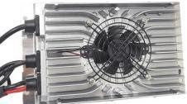
 | 24 | 30 | 50
ES- 2000w-2  Input ≤13A | 24 | 30 | 40 | 40 | 282  282 | 168  168 | 90  90 | 3.8  3.8 | 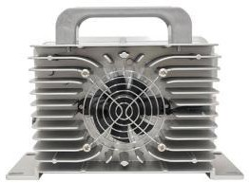  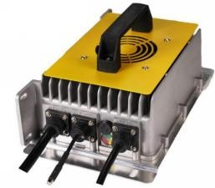
 | 36 | 45 | 40 | 30
 | 48 | 60 | 35 | 25
 | 60 | 75 | 30 | 20
 | 72 | 90 | 25 | 15
 | 80 | 100 | 22
 | 96 | 120 | 18 | 10
ES-2000w-P  Input ≤13A | 24 | 30 | 40 | 40
 | 36 | 45 | 40 | 30
 | 48 | 60 | 35 | 25
 | 60 | 75 | 30 | 20
 | 72 | 90 | 25 | 15
 | 80 | 100 | 22
 | 96 | 120 | 18 | 10

Model  OneE | Rated Voltage  （V) | Max charging Voltage (V) | Max output Current |  | Size  (mm) |  |  | Weight (kg) | Pictures
 |  |  | 220v AC | 110v AC | L | W | H
EX- 3000w  Input ≤15A | 24 | 30 | 50 | 25 | 315 | 198 | 114 | 8 | 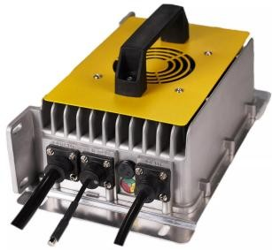
 | 36 | 49 | 50 | 25
 | 48 | 66 | 50 | 25
 | 60 | 85 | 35 | 17
 | 72 | 99 | 30 | 15
 | 96 | 115 | 30
 | 108 | 128 | 28
 | 144 | 180 | 20
ES- 3300w  Input ≤16A | 48 | 66 | 42 | 21 | 294 | 210 | 111 | 6 | 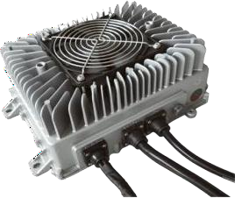
 | 60 | 82.5 | 40 | 20
 | 72 | 99 | 40 | 20
 | 84 | 116 | 40 | 20
 | 96 | 132 | 32 | 16
 | 120 | 144 | 25 | 12
 | 144 | 168 | 23 | 11
 | 160 | 198 | 15 | 7
 | 312 | 440 | 10 | 5

EV Chargers
Input Voltge |  |  | AC 90V-264V
Model | Type | Power | Size (mm) |  |  | Weight (kg) | Pictures
 |  |  | L | W | H
EQ-P  Portable EV Charger | GB/T | 3.5kw/16A  7kw/32A  11kw/16A  22kw/32A | / | / | / | 3kg
SAE/ J1772/
Type1
IEC/
Type2
EQ-W  EV Wallbox | GB/T | 3.5kw/16A  7kw/32A  11kw/16A  22kw/32A | 310 | 190 | 110 | 4kg | 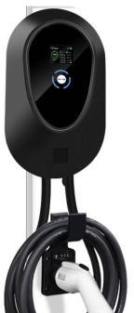
SAE/ J1772/
Type1
IEC/
Type2
EQ-E  EV Plug/socket  Extension Cable | GB/T | 16A  32A |  |  |  |  | 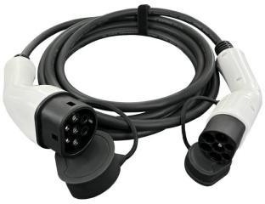
SAE/ J1772/
Type1
IEC/
Type2
EV Charger Accessories

EQ-A | SAE/Type1 pile to GB/T Car Type 1 to Type 2  Type 2 to GB/T | 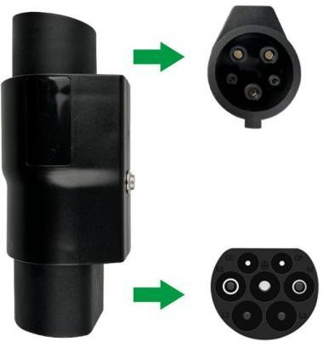
EQ-TP | Taking power from Pile SAE/J1772/Type1 Type2  GB/T
E1-TC | Taking power from Car SAE/J1772/Type1 Type2  GB/T | 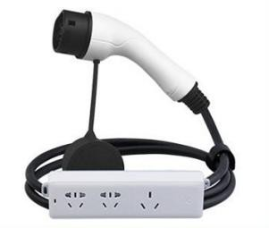
EQ-H | Plug holder
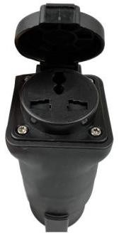
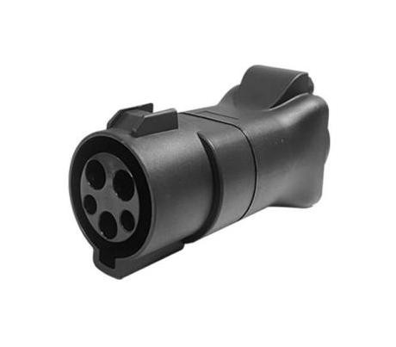

EQ-B | EV Charger Bag

